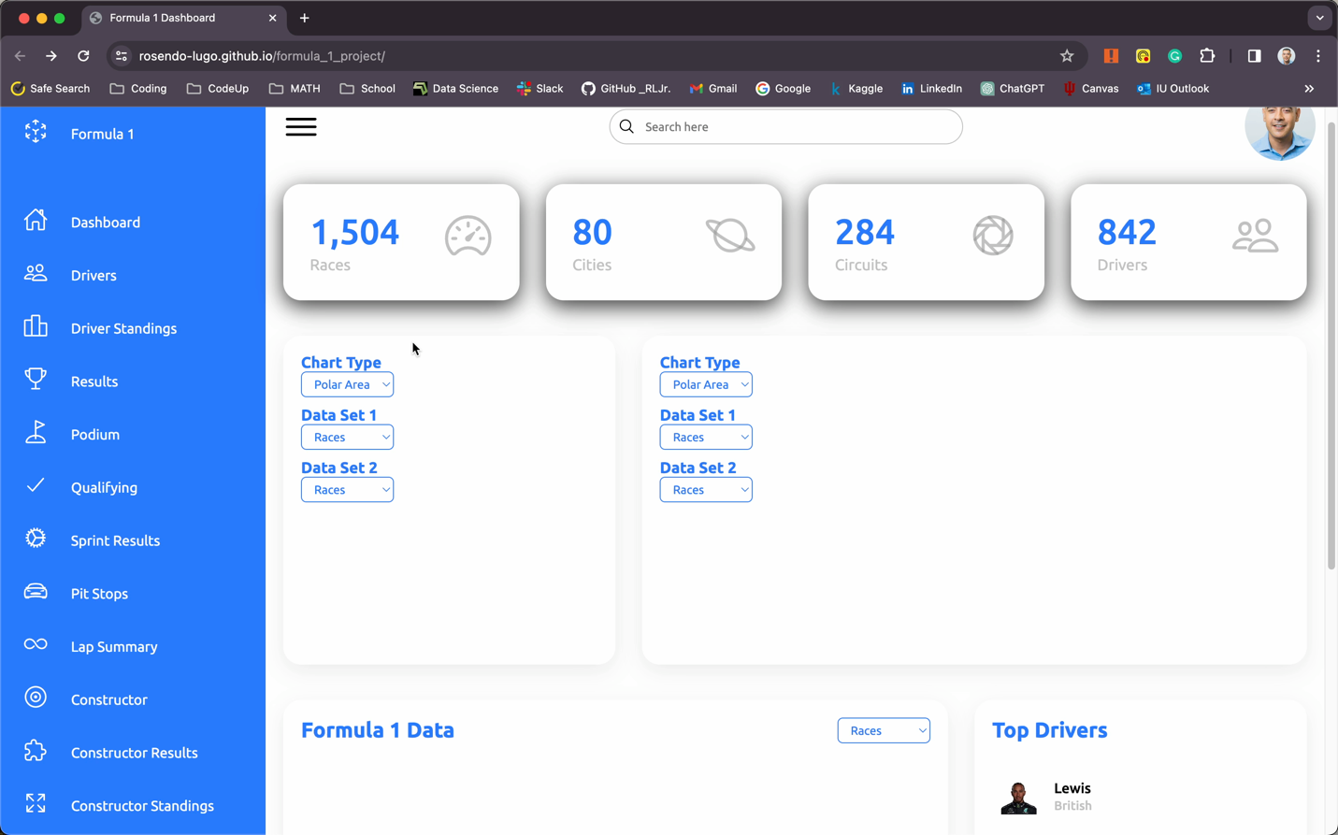Webpage link

<https://rosendo-lugo.github.io/formula_1_project/>

Github link

<https://github.com/rosendo-lugo/formula_1_project/settings/pages>